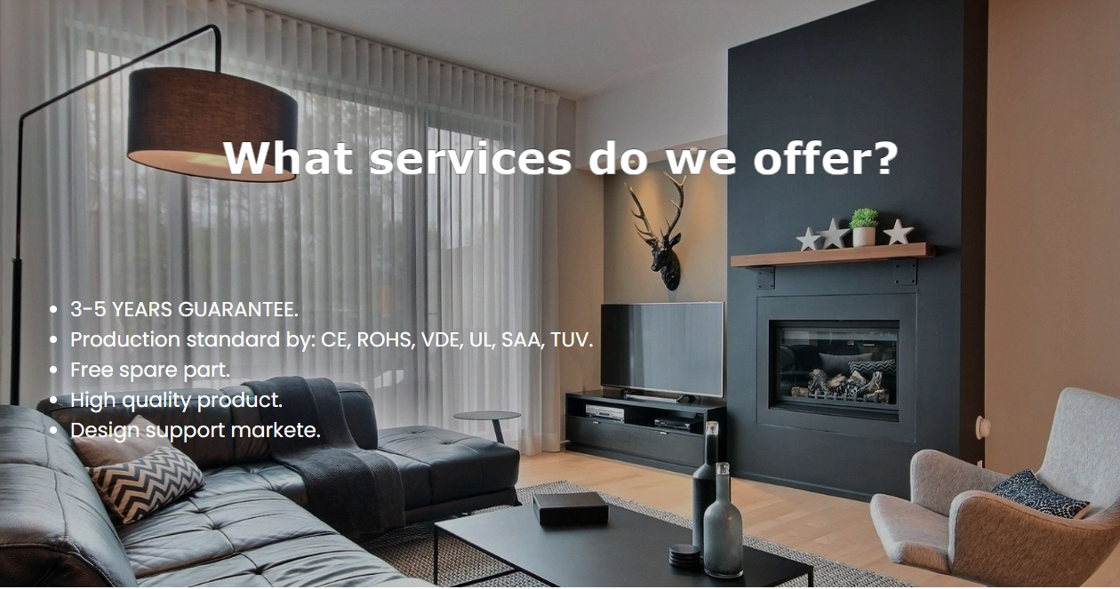

**Our Group.**

* Saif Ali
* Usama
* M. Taha

Chic Lighting

TABLE OF CONTENTS

Certification of Completion…………………………………………2

Acknowledgment…………………………………………………….3

Problem Statement………………………………………………….4

User Guide………………………………………………………5 to 7

Task Sheet……………………………………………………………8

Certification

Of Completion

HAS COMPLETED TO ALL REQUIRED STATEMENT IN THE PROJECT.

SIGNATURE DATE

ACKNOWLEDGEMENT

First of all we would like to thank Almighty **Allah** for giving us strength and ability to complete this project.

And then, we would like to express my special thanks of gratitude to our respected teacher **Sir Asif Ahmed Khan** who guided us on the project First Fashion, which also helped us in doing a lot of new learning and we came to know about so many new things we are really thankful to him.

We are highly thankful to **Sir Asif Ahmed Khan** for their guidance and constant supervision as well as for providing necessary information regarding the project & also for his support in completing the project.

Lastly, we would also like to thank our friends who helped us a lot in finalizing this project within the limited time frame. We also express our sincere gratitude to E-Project team from Aptech Head Office for their valuable guidance and support for the completion of this project.

We earnestly hope that this project will provide all the necessary information required by the user to fulfill his/her inspiration. However, suggestion and Feedbacks for improvements will be thankfully welcomed & acknowledged.

PROBLEM STATEMENT

Chic Lighting & Design is an online retailer that specializes in LED Lights, Lamps, Chandeliers and Pendant lighting. We have a range of collections that include; crystal chandeliers, traditional chandeliers, modern chandeliers, glass pendant lights, industrial and retro pendant lights, metal pendant lights and many more.

1) The Top of the Page should be presented with a suitable logo and images of Lights & Chandeliers.

2) The site must contain the various sections such as CEILING LIGHTS, WALL LIGHTS, LAMPS, OUTDOOR LIGHTS, FANS and HOME ACCENTS etc.

3) Section on LED Lights should be provided with various products listed such as Spot Lights, Decoration Lights, Smart Lights etc.

4) Specification and Pricing of Lights should be added along with the images.

5) A menu on the Top with all sections listed should be provided.

6) Website should provide section filter for various brands offered in the store.

7) Gallery section should be added for viewing different images.

8) Feedback must be allowed to enter by the viewer

9) Gallery, About us, FAQ link, Contact us must be added.

10) The complete description must be allowed to get download as pdf or doc file.

11) Section for various offers in the store should be provided with listing of offers with details.

USER GUIDE

* HOME PAGE

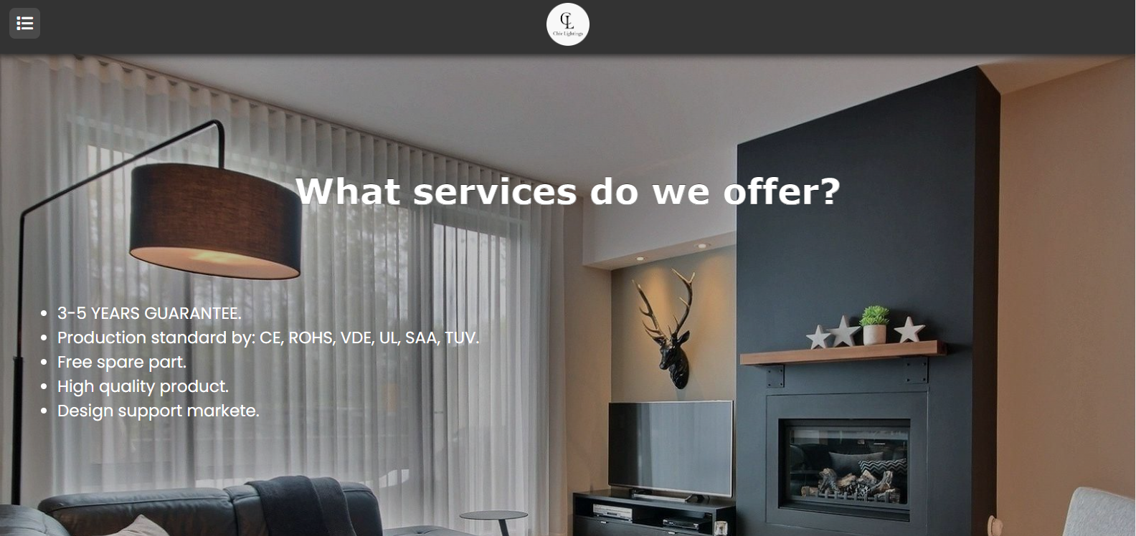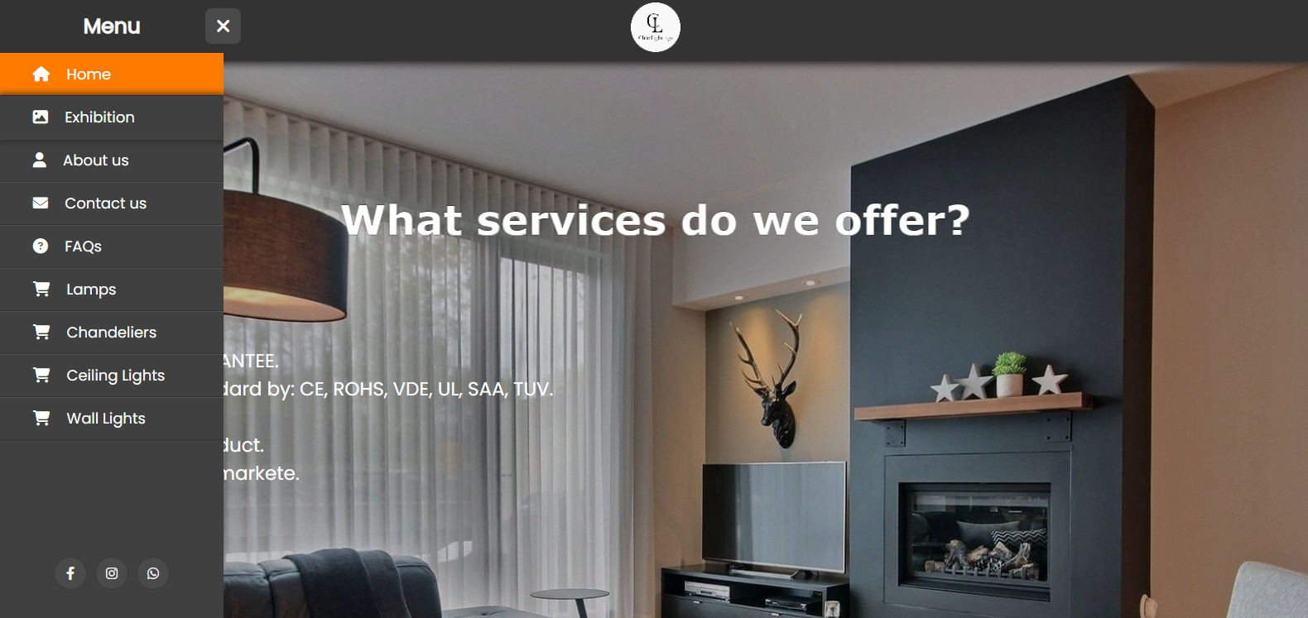**NAV-MENU & HEADER**

**FOOTER**

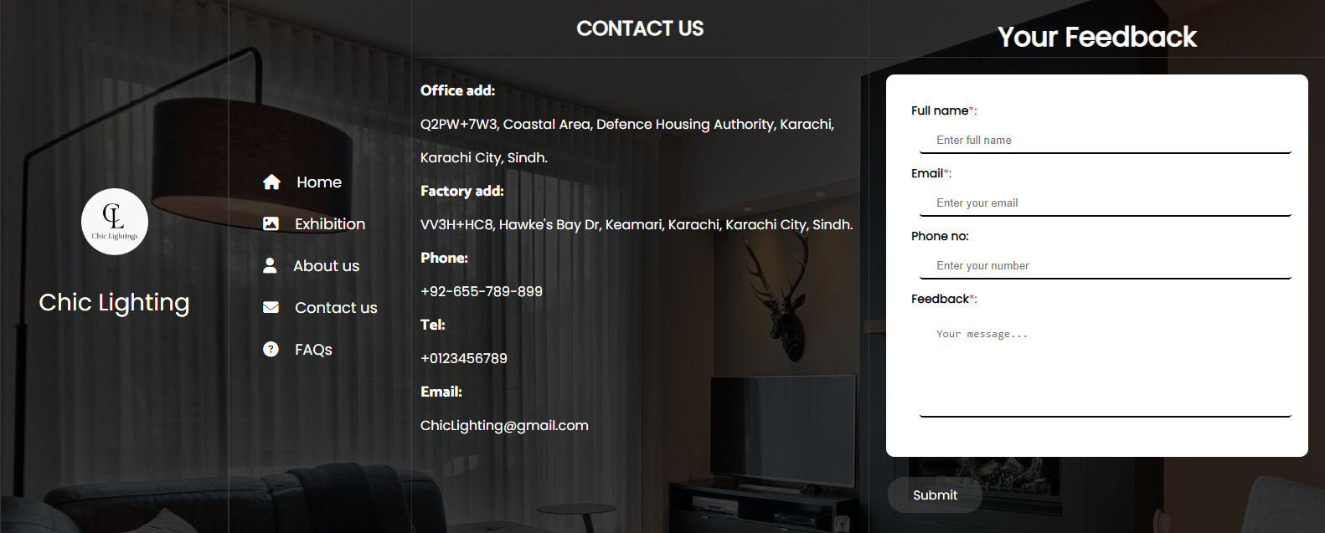

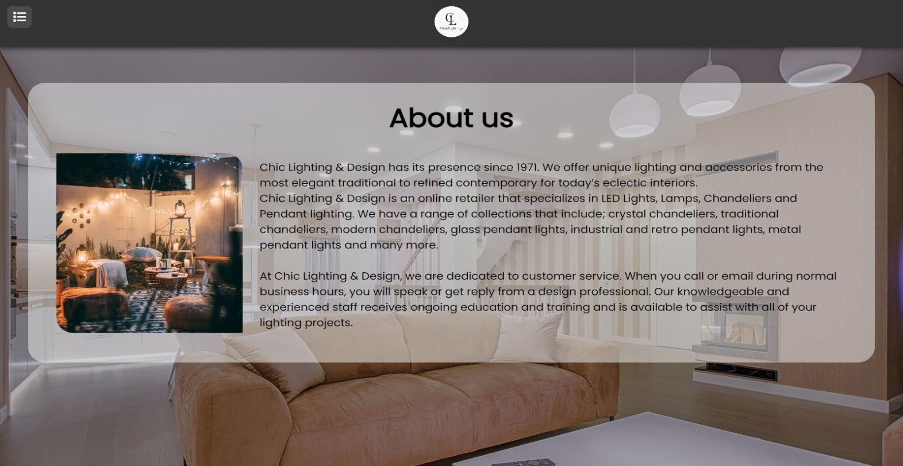**ABOUT US:**

* PRODUCT PAGES

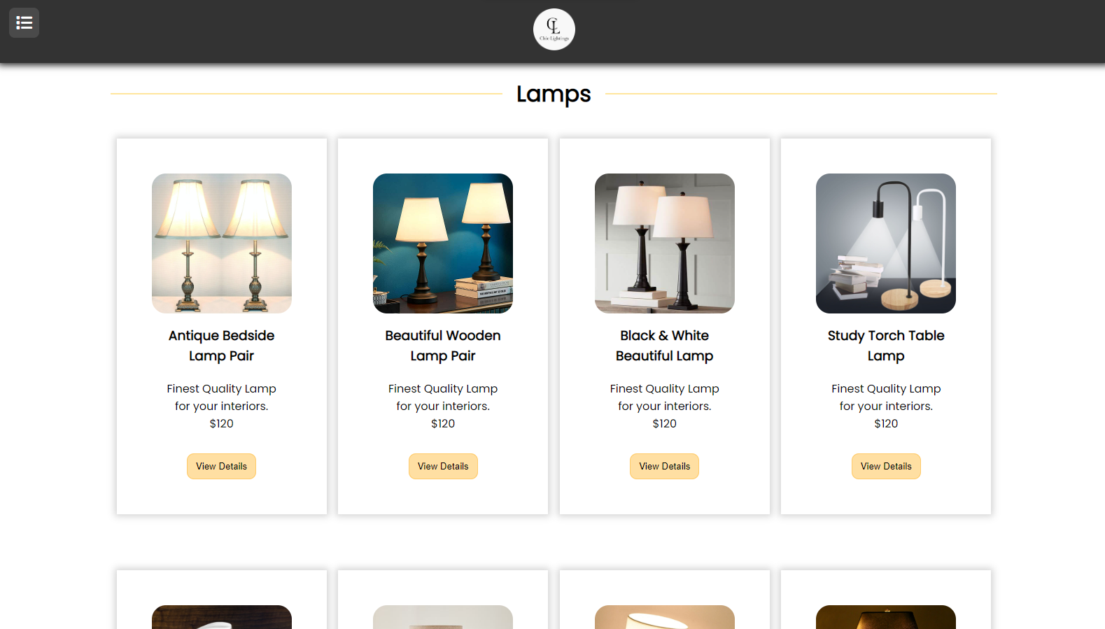**Lamps:**

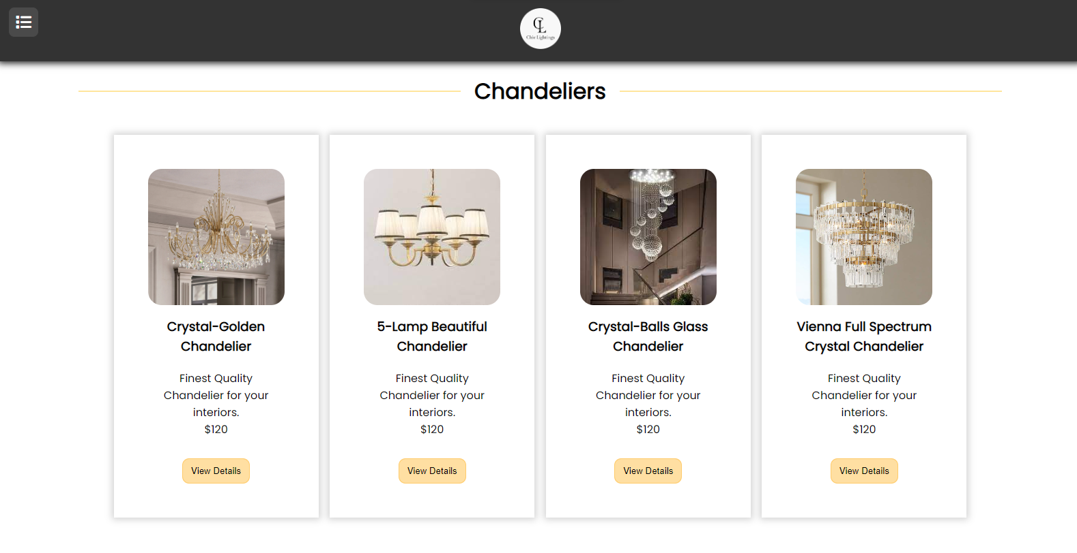**Chandeliers:**

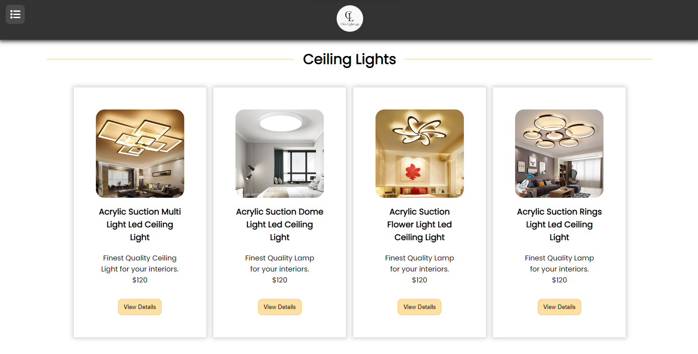**Ceiling Lights:**

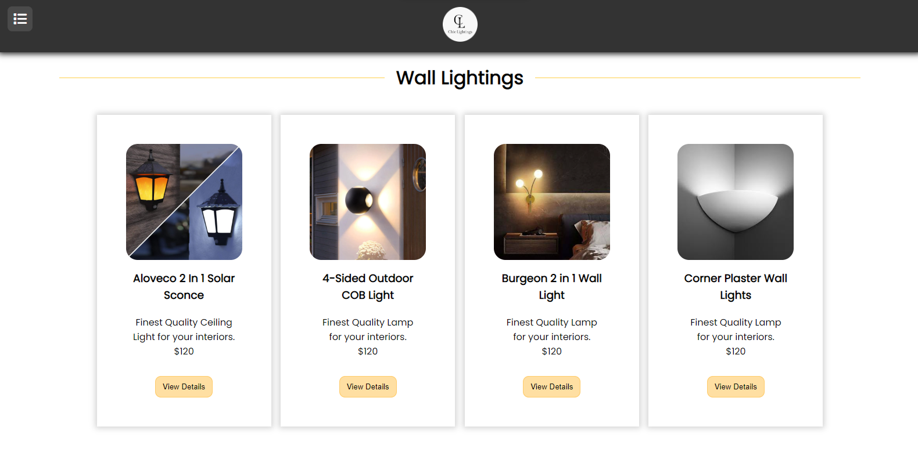**Wall Lights:**

TASK - SHEET